
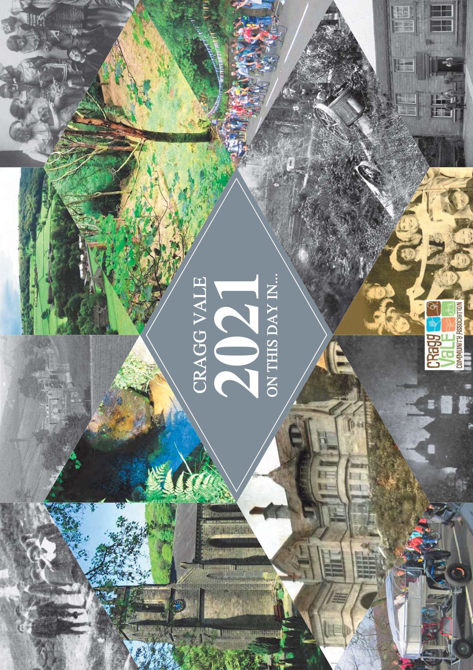
2021 Calendar “On This Day in ….”
£6 each
or 2+ at £5 each

Name: _________________________________________

Address: _________________________________________

Postcode: _________________________________________

Tel No: _________________________________________

Email: _________________________________________

Quantity required: __________________________________
Enquiries: Tel: Margaret 01422 885068 / 07900 00 4766
Order Form
Payment
Online banking preferred. Details will be provided on receipt of order. Alternatives available on request.

Delivery
Arrangements under Covid-19 conditions to be discussed.

Completed forms to be emailed to:
calendar@craggvalecommunity.co.uk

